


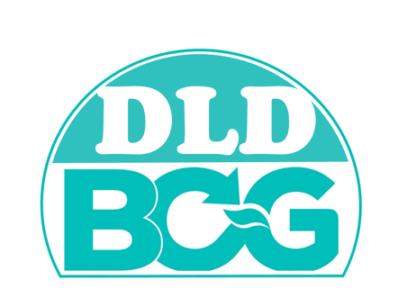

………………………………
( )
DIRECTOR OF REGIONAL LIVESTOCK 1
DEPARTMENT OF LIVESTOCK DEVELOPMENT
MINISTRY OF AGRICULTURE AND COOPERATIVES, THAILAND
THIS IS TO CERTIFY THAT

FARM ABC 1 (PIG FARM)
1 MOO 1, NONG KOP, NONG SAENG, SARABURI
CERTIFICATION NO. AC-22-06403-19-0001 BCG
HAS APPROVED ON BCG ECONOMY MODEL
AS LIVESTOCK FARM WHICH CONSERVE
NATURAL AND BIOLOGICAL RESOURCES
FOR SUSTAINABLE DEVELOPMENT IN LIVESTOCK SECTOR

DATE OF CERTIFY : 4th DECEMBER 2023
VALID UNTIL : 3rd DECEMBER 2026

